Personal Information
First name:
Last name:
Mailing address:
Address Line 2:
City:
State:
Zip:

Measurements
Height:
Weight (don’t worry, we keep this a secret):
Bust or chest measurement:
Arm length:
Shoulder tip to shoulder tip:

Base Price: $324 + shipping

Style Options
Style number desired (1-81) [See below for design options]: Note Number Here

Parka Ruff Fur
(See below for details)

Raccoon +$0 ☐
Fox +$20 ☐
Lining
Rex Rabbit +$0 ☐
Raccoon + $50 ☐
Fox + $200 ☐

Length desired
Regular length (above the knees) +$0 ☐
X-Long (below the knees) +$20 ☐

Total: $
($324 + add-ons):

Preferred Payment method:
PayPal☐
Check☐
Card☐
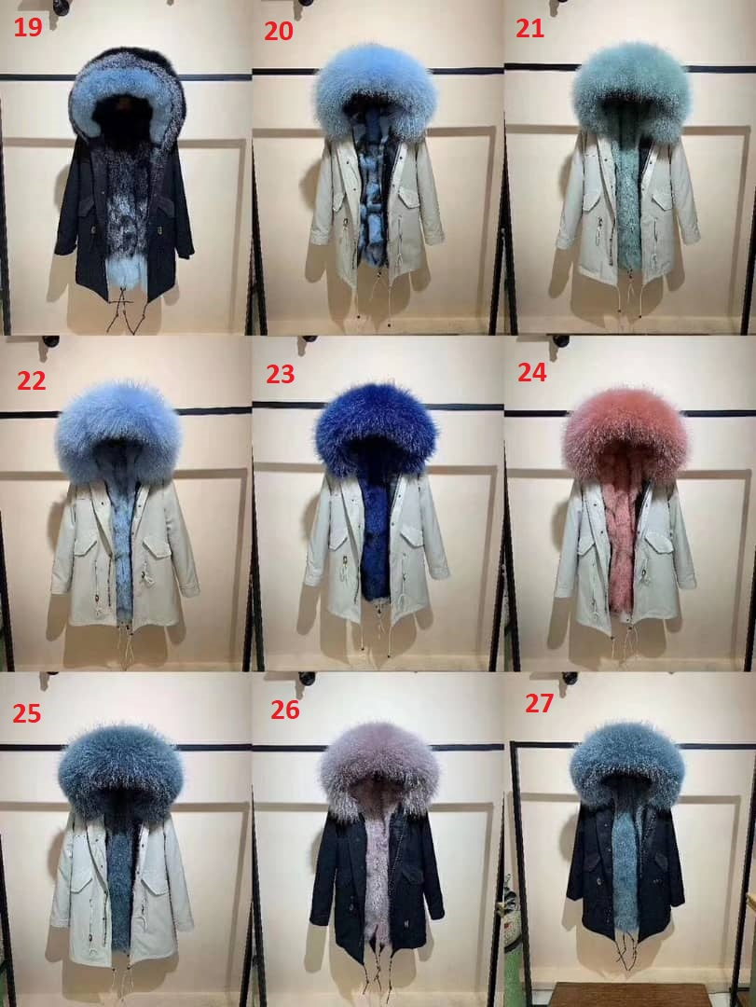
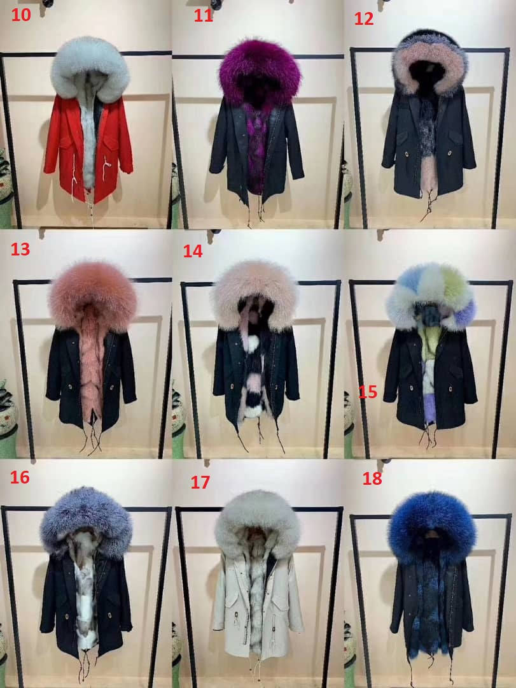
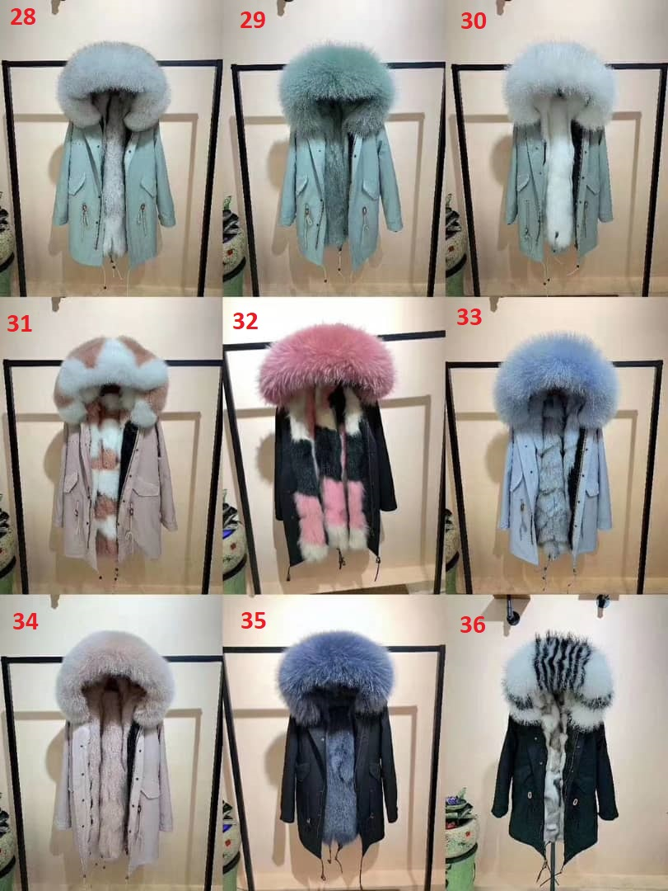
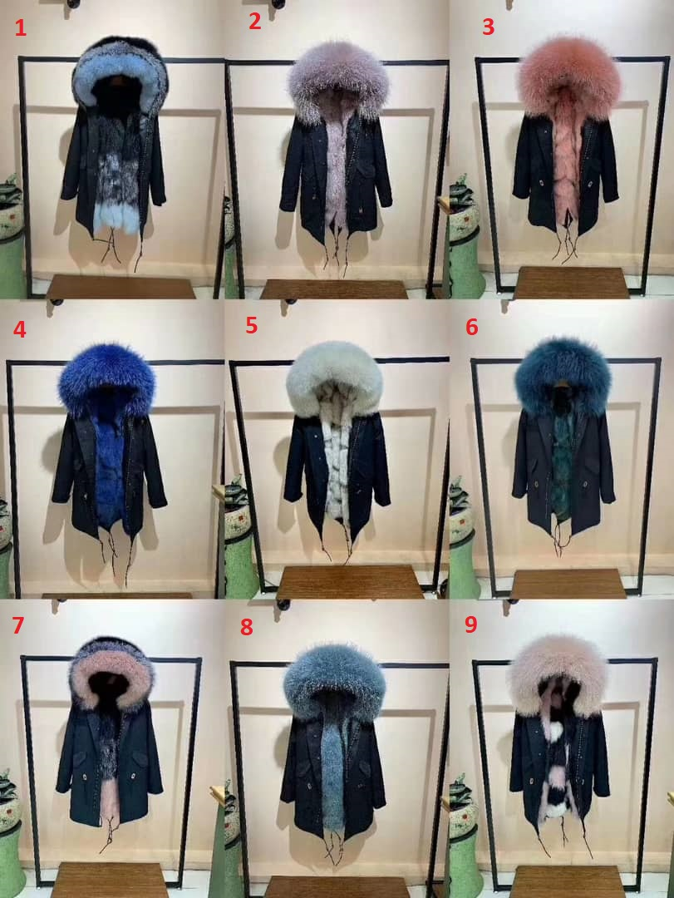

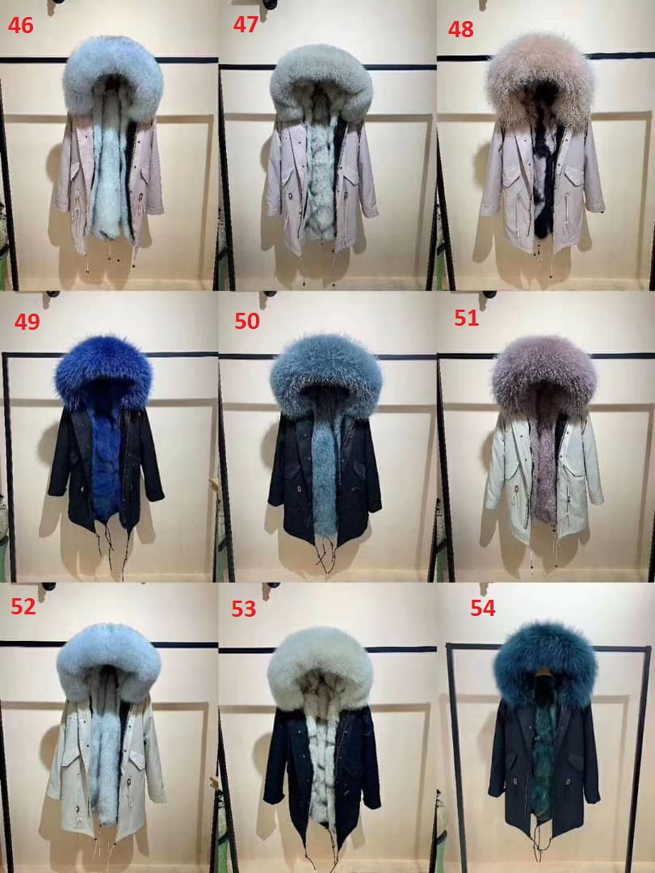
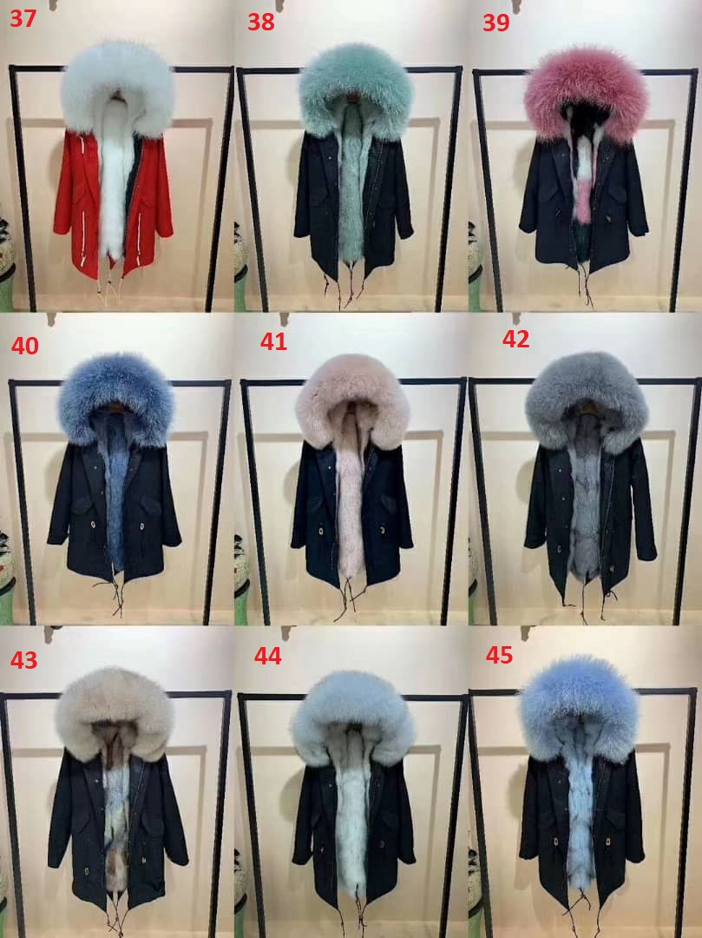

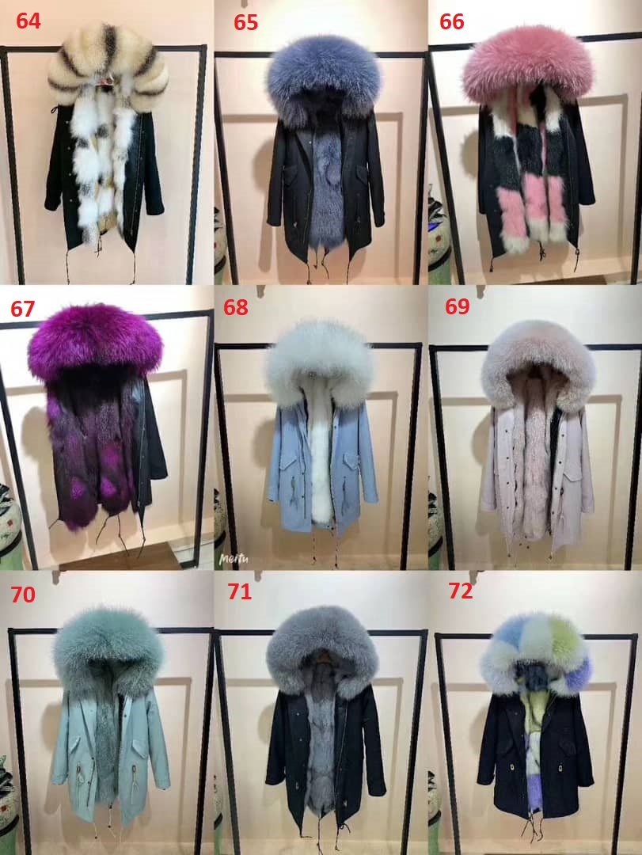
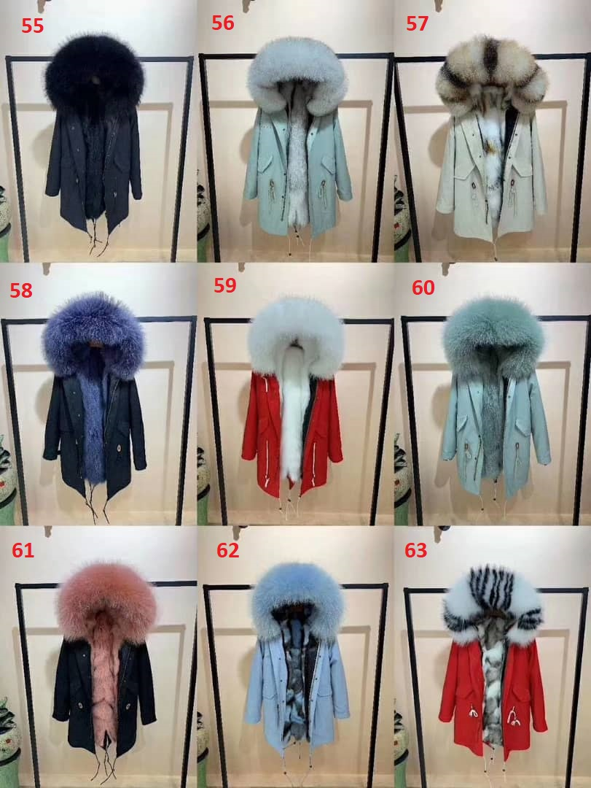
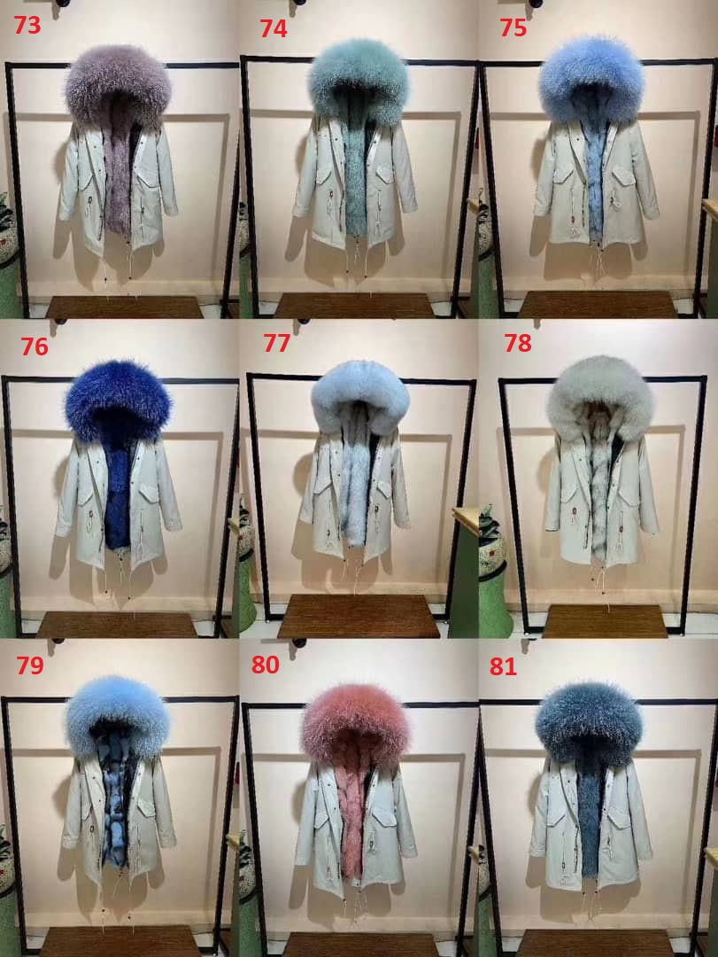

Parka Ruff Options

Raccoon (color will vary depending on style)
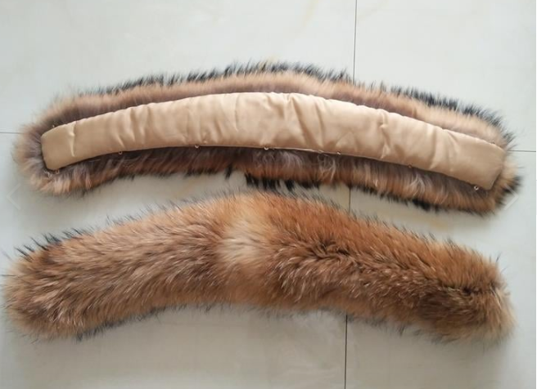

Fox (color will vary depending on style)
